**DATA201/422 Group project**

Anna McCarthy

Thomas Arnold

Zheng Chao(zch65)   21671773

Ezeckiel Mautoatasi

This report aims to demonstrate our group's process from initial design to final proposal. It contains interesting data sources that we identify to process, organize them into a suitable target data model and present this data to a wider audience.

Our team came up with a number of different ideas during the prototyping process, some of the initial topic ideas included looking into the number of reported cases of rule breakers in Christchurch region during the lockdown. Also, we looked at comparing the number of road works in the Christchurch area over time. Due to difficulties with obtaining data of some of these topic areas. After looking for available data sets, we decided to making playlists of NZ music for Christchurch cafes.

By taking the names of a cafés in Christchurch and splitting their names into characters, we matched each character with a New Zealand artist whose name started with the character and selected one of their songs to go into the custom playlist. To obtain the required information we scraped several websites to get data about the cafes around Christchurch as well as information about New Zealand artist and their songs.

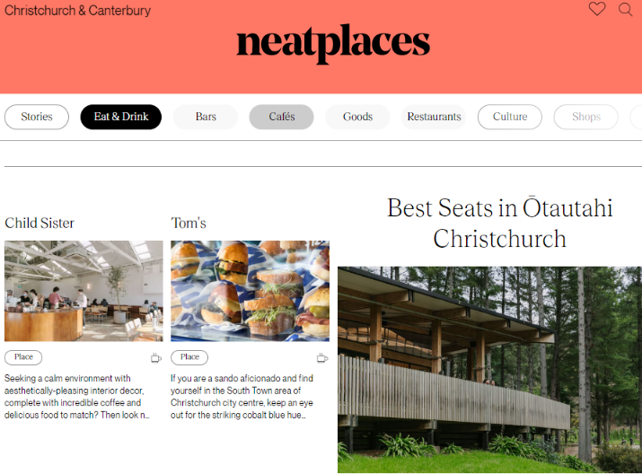The first data source that we needed was a list of Christchurch café names, we had some difficulties finding a website that stored the information inside a class with no other information inside of it. Neatplaces is a website that stores information about all shops, bars, cafes, and restaurants in New Zealand. We were able to scrape the café names easily using the read_html() function because the names were in a class that had nothing else inside of it.

<https://neatplaces.co.nz/places/christchurch-canterbury/eat-drink/cafes>

The second data source that we needed we information about New Zealand artists which we found on a website called audioculture which contains all of New Zealand’s artists as some of their songs.

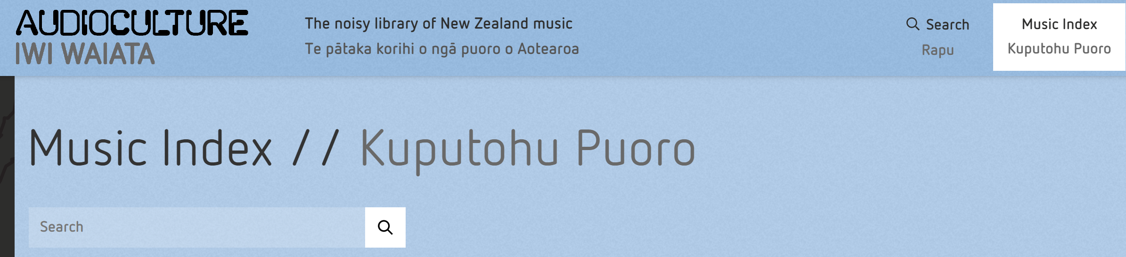

<https://www.audioculture.co.nz/music_index?category=Person>

1. what data sources you used
2. why you chose those data sources
3. what target you chose (i.e., what is the intended use of the data, ...)
4. what difficulties you had to overcome to wrangle the data sources into the target data model
5. what techniques you did use
6. what you managed to achieve and what you failed to do

**Cleaning Data**(what techniques you did use)

**-Christchurch cafe names data**

-**NZ music data**

-Discussion(what difficulties you had to overcome to wrangle the data sources into the target data model)

-Evaluation(what you managed to achieve and what you failed to do)

-Conclusion

The initial idea is to explore how people's lives in New Zealand have changed under different levels of lockdown, including social security, mental health, and food delivery. We found the data set and produced it in csv format. By using code to organize data, we found that the Canterbury area we are interested in increases with the level of lockdown, and 105 reports also become more and more. At level 4, the number of cases even exceeds that of Auckland, which is the most populous area. This means that social security in the Canterbury region is the worst in New Zealand during lockdown level 4.

